Test Case: tc001_SPX_Dev5_Crear_Requisicion_Spot_Tipo_Cobro_CC
Step 1 - Enter username and password and click to button Enter : Credentials Entered
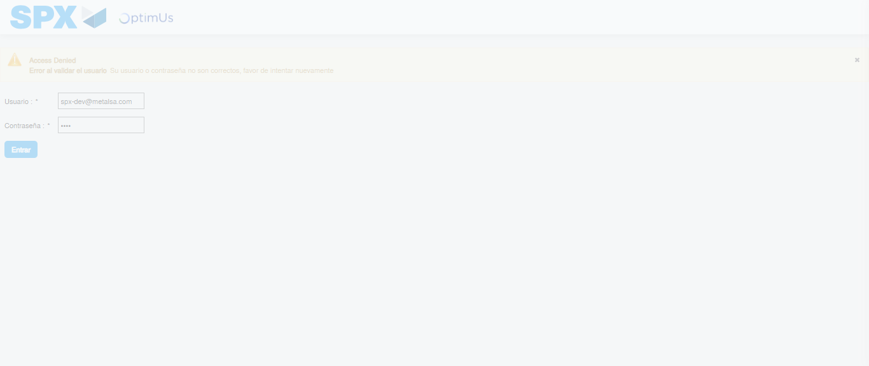Image file-name: QC_Testing-tc001_SPX_Dev5_Crear_Requisicion_Spot_Tipo_Cobro_CC-1784569564201

Step 2 - Select to UEN and Access to Spot Buy Requisitions : UEN Correctly selected and Correct access
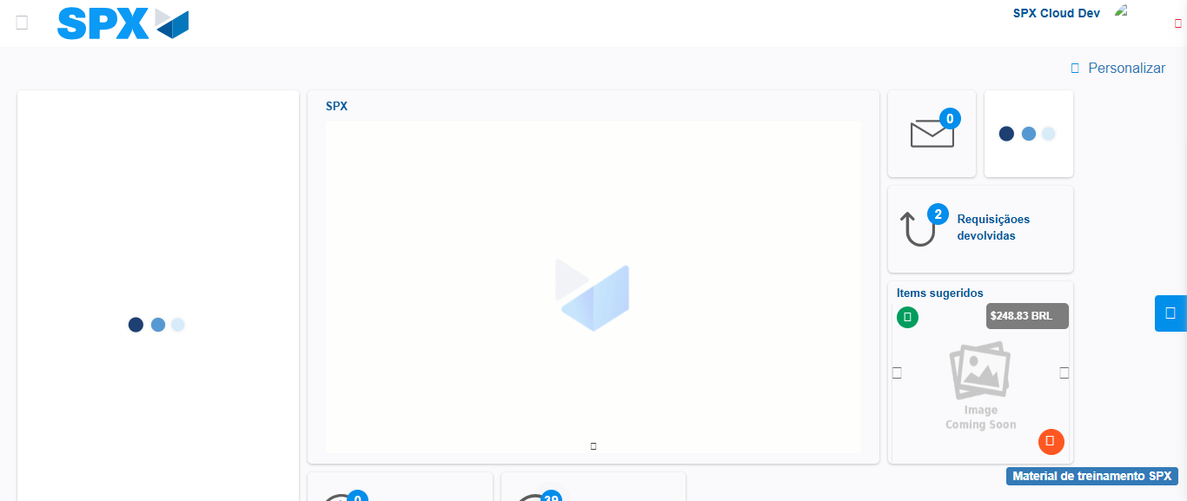Image file-name: QC_Testing-tc001_SPX_Dev5_Crear_Requisicion_Spot_Tipo_Cobro_CC-1784569593131

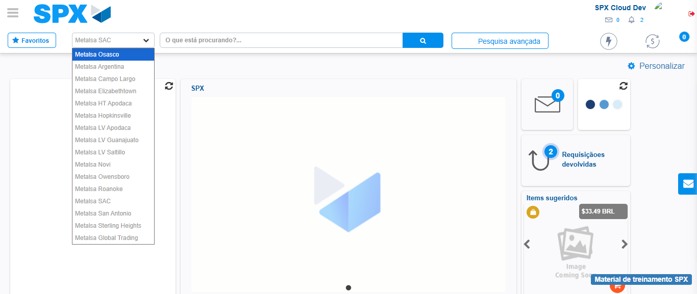Image file-name: QC_Testing-tc001_SPX_Dev5_Crear_Requisicion_Spot_Tipo_Cobro_CC-1784569605351

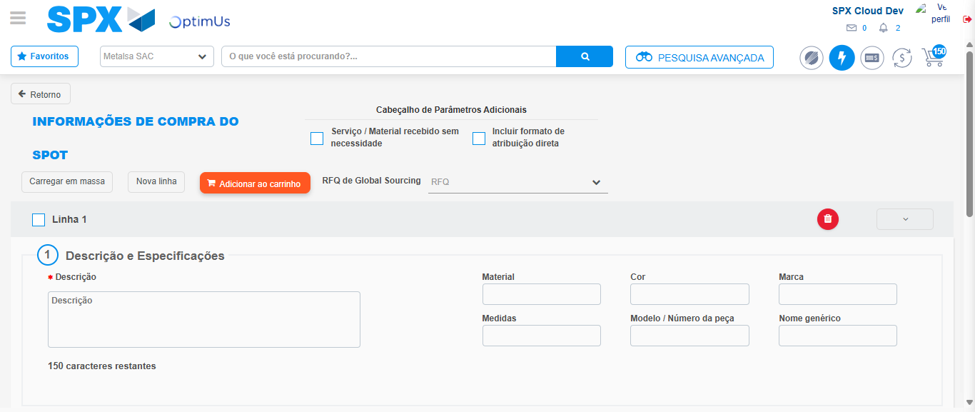Image file-name: QC_Testing-tc001_SPX_Dev5_Crear_Requisicion_Spot_Tipo_Cobro_CC-1784569613157

Step 3 - Data Capture Spot Buy Requisition : Data captured correctly
Image file-name: QC_Testing-tc001_SPX_Dev5_Crear_Requisicion_Spot_Tipo_Cobro_CC-1784569613434

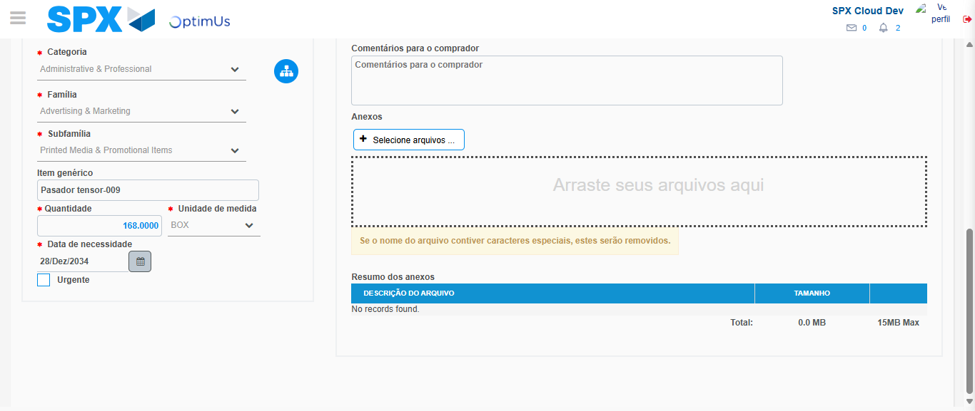Image file-name: QC_Testing-tc001_SPX_Dev5_Crear_Requisicion_Spot_Tipo_Cobro_CC-1784569626850

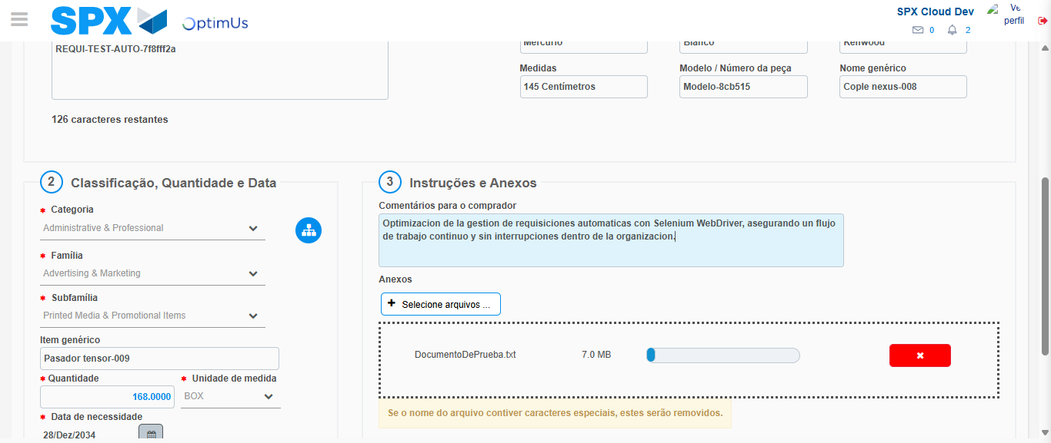Image file-name: QC_Testing-tc001_SPX_Dev5_Crear_Requisicion_Spot_Tipo_Cobro_CC-1784569627827

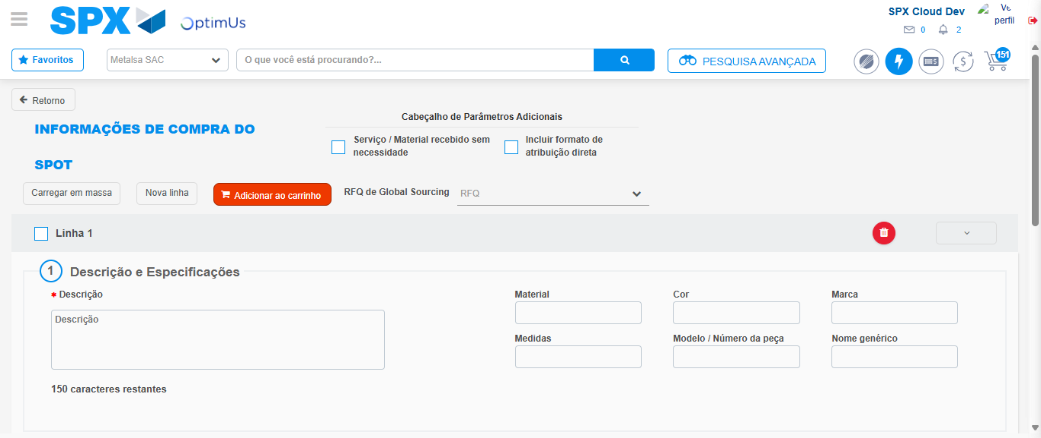Image file-name: QC_Testing-tc001_SPX_Dev5_Crear_Requisicion_Spot_Tipo_Cobro_CC-1784569637050

Step 7 - Return to Main Page SPX : Return to Main Page SPX
Image file-name: QC_Testing-tc001_SPX_Dev5_Crear_Requisicion_Spot_Tipo_Cobro_CC-1784569593131

Image file-name: QC_Testing-tc001_SPX_Dev5_Crear_Requisicion_Spot_Tipo_Cobro_CC-1784569605351

Image file-name: QC_Testing-tc001_SPX_Dev5_Crear_Requisicion_Spot_Tipo_Cobro_CC-1784569613157

Image file-name: QC_Testing-tc001_SPX_Dev5_Crear_Requisicion_Spot_Tipo_Cobro_CC-1784569639297

Image file-name: QC_Testing-tc001_SPX_Dev5_Crear_Requisicion_Spot_Tipo_Cobro_CC-1784569639496

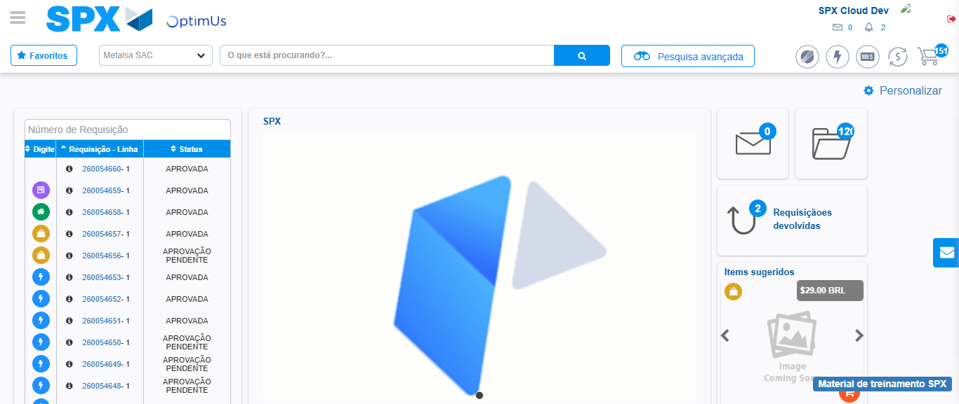Image file-name: QC_Testing-tc001_SPX_Dev5_Crear_Requisicion_Spot_Tipo_Cobro_CC-1784569660730

Step 8 - Log Out : Log Out SPX
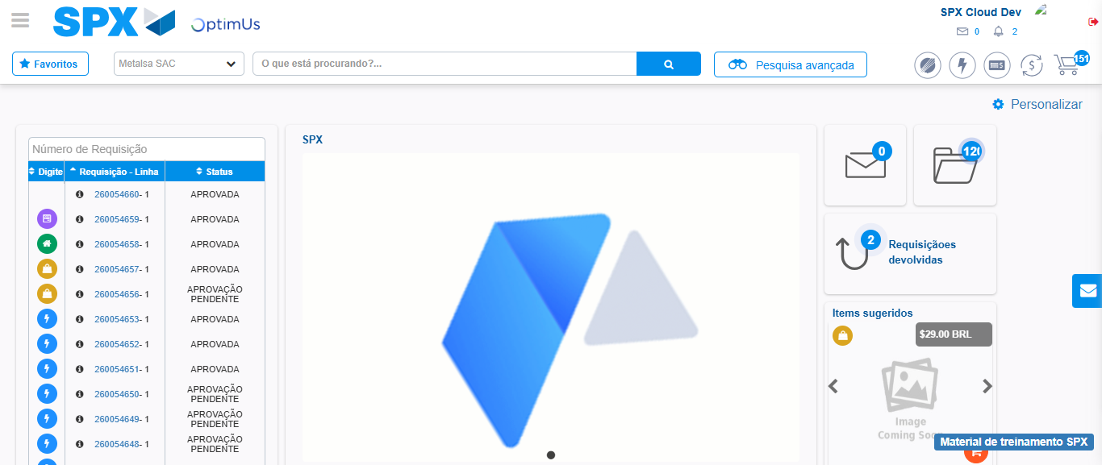Image file-name: QC_Testing-tc001_SPX_Dev5_Crear_Requisicion_Spot_Tipo_Cobro_CC-1784569661110

